Quantitative Research Design generated by <<Name>>
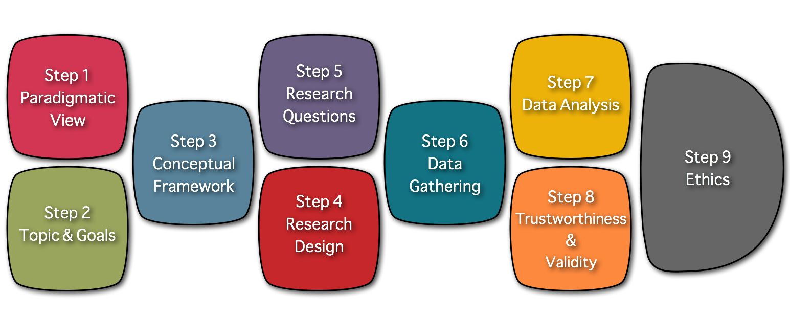

Personal Data
Name: <<Name>>
email: <<email>>
Date: <<Date>>

Step 1: Paradigmatic View of the Researcher
The Worldview you will be bringing to the study is: <<How would you define your Worldview?>>

Step 2: Topic & Goals of your study
Description of your Research Topic: <<Research Topic>>

Personal goals driving your study: <<Please describe the personal goals that drive you to conduct this study>>

Practical goals driving your study: <<Please describe the practical goals that drive you to conduct this study>>

Intellectual goals driving your study: <<Please describe the intellectual goals driving you to conduct this study>>

Step 3: Conceptual Framework of your study
Topical Research: <<Topical Research >>

Gaps identified in the field: <<Gaps identified in the field>>

Theoretical Frameworks: <<Theoretical Frameworks>>

Problem Statement: <<Problem Statement>>

Step 4: Research Design
The Research Design you will be using is: <<Which research design works better for the study you have in mind? >>

Link to the Visual representation of your <<Which research design works better for the study you have in mind? >> : <<Visual representation>>

Step 5: Research Questions
<<Please include below the research questions driving your study. Please be advise that your questions will depend on the research tradition selected in the previous stage>>

Step 6: Data Gathering Methods
The data Gathering Methods you will be using in your study are : <<Which data gathering method will you use in your study>>

Step 7: Data Analysis Methods
The data Analysis Methods you will be using in your study are : <<Please define the analysis methods you will use in your study>>

Step 8: Validity & Reliability
The strategies you will use to ensure the validity and reliability of your study are : <<Which are the strategies you will use to control the validity of your study?>>

Step 9: Ethical principles driving your study
The ethical principles that will be driving your study are : <<Which major ethical principles will drive your study?>>

Visual Representation of your Conceptual Framework

Research Topic
<<Research Topic>>

Topical Research |  | Theoretical Frameworks
<<Topical Research >> |  | <<Theoretical Frameworks>>
Gaps identified in the field
<<Gaps identified in the field>>
Problem Statement
<<Problem Statement>>
Research Questions
<<Please include below the research questions driving your study. Please be advise that your questions will depend on the research tradition selected in the previous stage>>
Research Design
<<Which research design works better for the study you have in mind? >>
<<Visual representation>>

